Group Members :

# Names Roll No

L1F22BSCS0002 KUSHBAKHT USMAN

L1F22BSCS0036 HIRA HAIDER

L1F22BSCS0017 ABDUL HANNAN

L1F22BSCS0020 AMMAR KHAN

L1F22BSCS0029 ZAIN RAFIQUE

Subject : English

Section : D-12

Subject Teacher : Faiza ISHFAQ

Title: "Make-A-Video and Image Generator: Advancing Text-to-Visual Synthesis through Unified Spatial-Temporal AI Models"

# Executive Summary:

In recent years, AI technologies capable of generating images from text prompts have become increasingly prevalent in society and design. Advanced Text-to-Image (T2I) tools, such as Midjourney, DALL-E 2, and Disco Diffusion, allow users to create visually compelling images from textual descriptions. These AI-generated images are not only popular on social media but also find applications in art projects, documents, and publications. This exploratory study investigates whether these modern T2I AI systems can effectively replace human designers in the initial concept generation stage of engineering design. The study involved design students evaluating AI-generated concepts to determine their usability and creative potential in engineering contexts. The findings highlight that while T2I tools are effective in generating a broad range of innovative design ideas, they face barriers such as precision and specificity, which are crucial in engineering design. Despite these limitations, AI offers substantial support in the ideation phase but still requires human intervention for refinement and contextual adaptation. To address these challenges, the study suggests short-term enhancements in AI capabilities and calls for long-term research to develop AI systems that can better understand and generate contextually relevant and technically detailed outputs for seamless integration into professional design workflows.

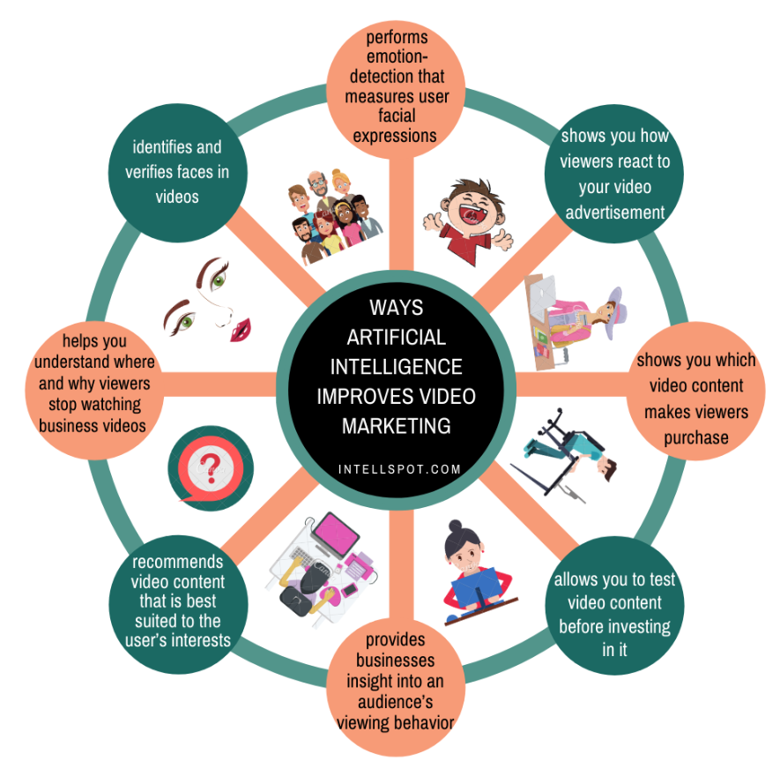

# Introduction :

## In the recent years, AI has made significant strides in Text-to-Image (T2I) synthesis, leveraging techniques like GANs and transformers to interpret textual descriptions and produce detailed images. This progress has sparked interest in extending these capabilities to Text-to-Video (T2V) synthesis. However, generating coherent videos from text presents challenges in capturing temporal consistency and dynamics. Traditional methods often rely on extensive paired data, leading to resource-intensive and complex processes.

## Purpose:

The research proposal aims to:

1. Bridge the Gap between T2I and T2V Technologies: Leveraging recent T2I advancements to develop a unified model proficient in T2V synthesis, adapting learned representations to handle motion and temporal dynamics.

2. Evaluate and Enhance AI in Design Processes: Assessing T2I and T2V models' potential to aid or replace human designers in concept generation, ensuring alignment with professional workflows.

3. Address Barriers and Expand Applications: Overcoming limitations in generating high-quality visuals, exploring methods to enhance diversity and meet aesthetic standards without extensive paired datasets.

4. Set New Benchmarks in Text-to-Visual Synthesis: Establishing benchmarks for T2I and T2V model performance, focusing on resolution, temporal coherence, fidelity to text, and overall visual quality.

5. Guide Future Research and Development: Providing a roadmap for future advancements, including short-term model enhancements and long-term integration with human designers.

## Discussions:

#### 1. Integration of T2I and T2V Technologies

In this part, we delve into the technical intricacies of bridging Text-to-Image (T2I) and Text-to-Video (T2V) synthesis. We discuss the challenges of extending T2I models to handle temporal dynamics and motion inherent in videos. Specifically, we explore techniques for adapting spatial-temporal architectures, such as temporal U-Nets and attention mechanisms, to effectively process video sequences generated from textual descriptions. We highlight the importance of preserving both spatial and temporal coherence in the generated visuals to ensure fidelity to the input text.

#### 1. Technical Considerations and Integration

In the technical aspect of the discussion, we delve into the intricacies of integrating Text-to-Image (T2I) and Text-to-Video (T2V) technologies. This involves adapting existing T2I models to handle temporal dynamics and motion in video synthesis. We discuss the implementation of spatial-temporal architectures, such as temporal U-Nets and attention mechanisms, to process video sequences generated from textual descriptions effectively. Additionally, we explore techniques for optimizing computational efficiency and model scalability to handle large-scale video generation tasks.

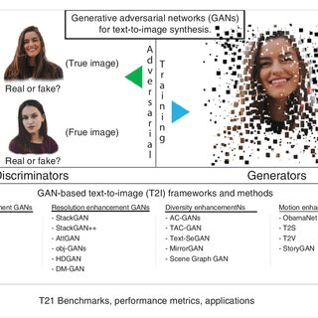

#### 2. User Interface (UI) and User Experience (UX) Design

Effective UI/UX design is crucial for ensuring user-friendly interaction with the proposed AI system. We discuss the design principles and considerations for developing intuitive interfaces that facilitate seamless interaction with the AI model. This includes designing clear and intuitive input mechanisms for textual descriptions, visualizing the generated outputs in a comprehensible manner, and providing interactive features for real-time feedback and customization. We emphasize the importance of iterative user testing and feedback to refine the UI/UX design and enhance user satisfaction and engagement.

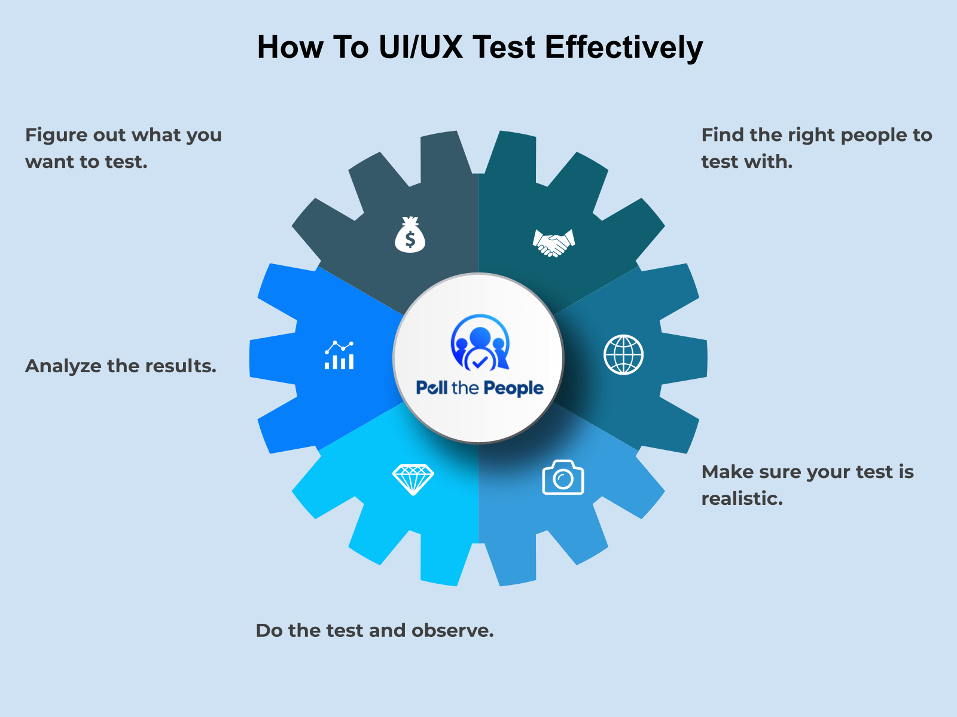

#### 3. Cost Analysis and Resource Allocation

A comprehensive cost analysis and resource allocation plan are essential for the successful development and deployment of the proposed AI system. We discuss the financial requirements, including software licensing, hardware infrastructure, personnel salaries, and operational expenses. We analyze strategies for optimizing resource allocation to maximize cost-effectiveness while ensuring the system's performance, scalability, and reliability. Additionally, we explore potential sources of funding and investment opportunities to support the project's implementation and sustainability.

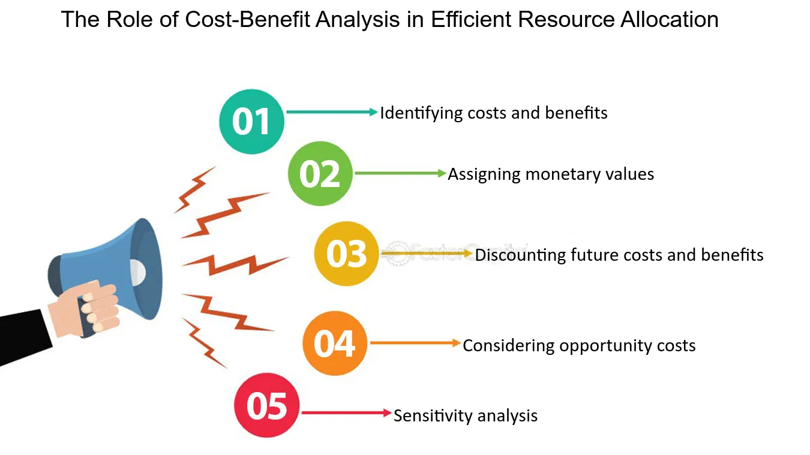

#### 4. Delivery Management and Project Governance

Effective delivery management and project governance are critical for ensuring the timely and successful completion of the research project. We discuss strategies for project planning, scheduling, and monitoring to track progress and mitigate risks effectively. This includes establishing clear objectives, milestones, and deliverables, assigning roles and responsibilities to team members, and implementing mechanisms for communication and collaboration. We emphasize the importance of agile project management methodologies to adapt to changing requirements and stakeholder feedback dynamically.

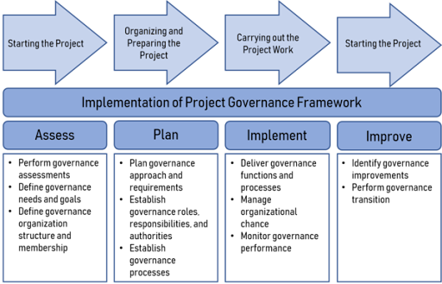

#### 5. Machine Learning Integration and Model Training

The integration of machine learning techniques is central to the development of the proposed AI system. We discuss strategies for training and fine-tuning the T2I and T2V models using large-scale textual and visual datasets. This includes preprocessing and data augmentation techniques to enhance model robustness and generalization. We explore approaches for incorporating transfer learning and domain adaptation to leverage pre-trained models and adapt them to specific application domains effectively. Additionally, we discuss strategies for model evaluation and validation to ensure the quality and reliability of the generated outputs.

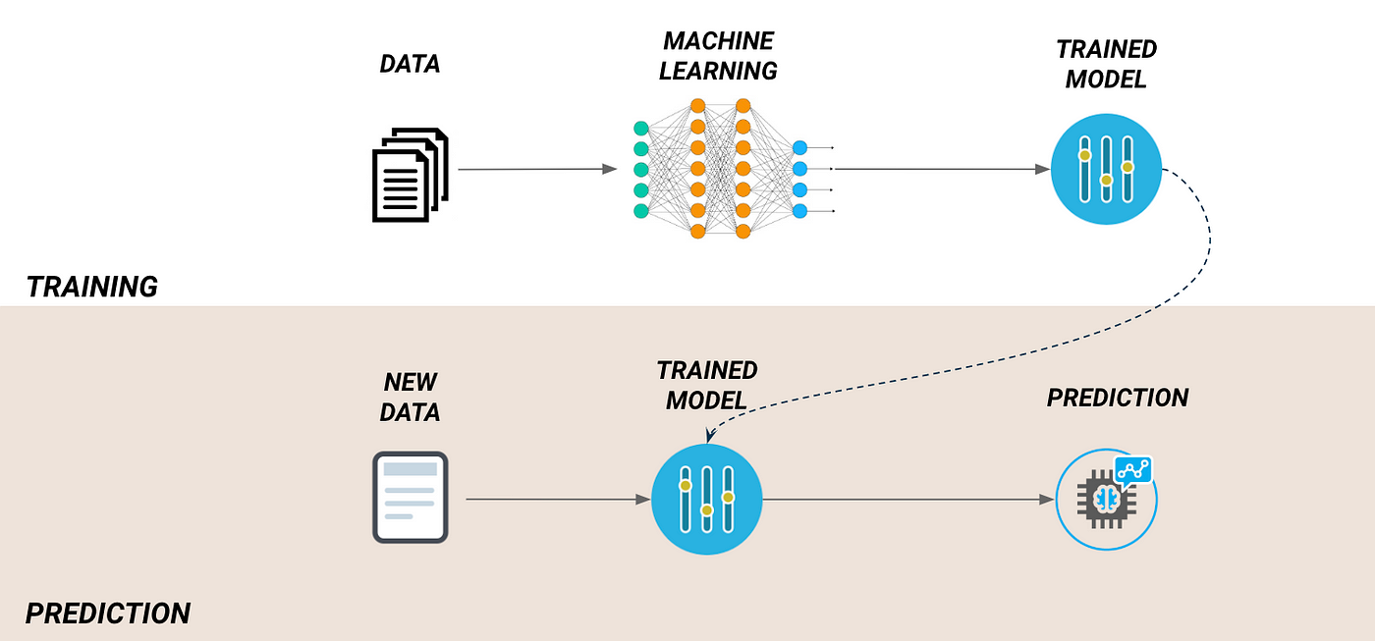

#### 6. Evaluation of AI-Generated Concepts in Design Processes

Our study involves evaluating AI-generated design concepts in the context of engineering design workflows. We discuss the methodologies employed, including team-based evaluations by design students and criteria for assessing usability, creativity, and feasibility. We analyze the strengths and limitations of AI-generated concepts compared to those generated by human designers, focusing on factors such as novelty, practicality, and alignment with design objectives.

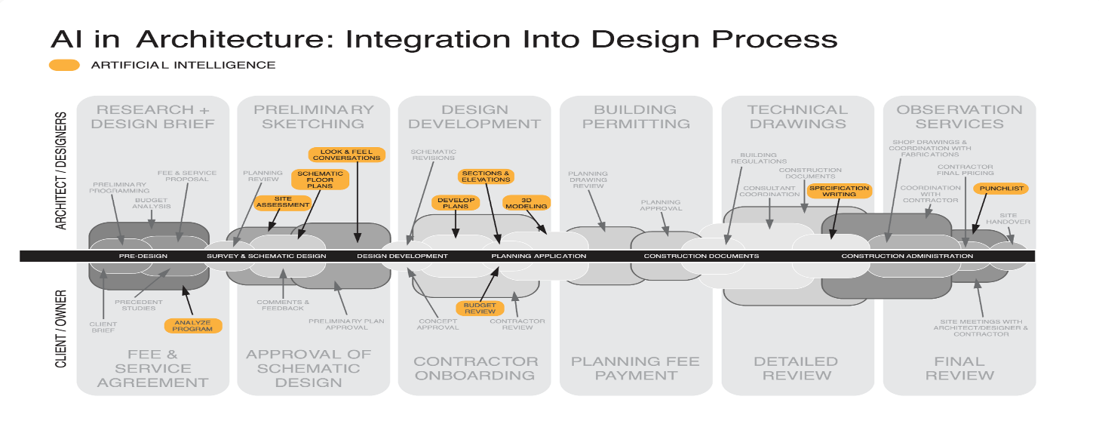

#### 7. Barriers and Challenges in AI Adoption for Engineering Design

We identify and discuss the barriers hindering the widespread adoption of AI tools in engineering design processes. These barriers include the need for AI systems to generate technically precise and contextually relevant designs, as well as challenges in integrating AI outputs with existing design practices. We explore potential solutions and strategies for overcoming these barriers, such as improving AI models' understanding of engineering requirements and developing user-friendly interfaces for seamless human-AI collaboration.

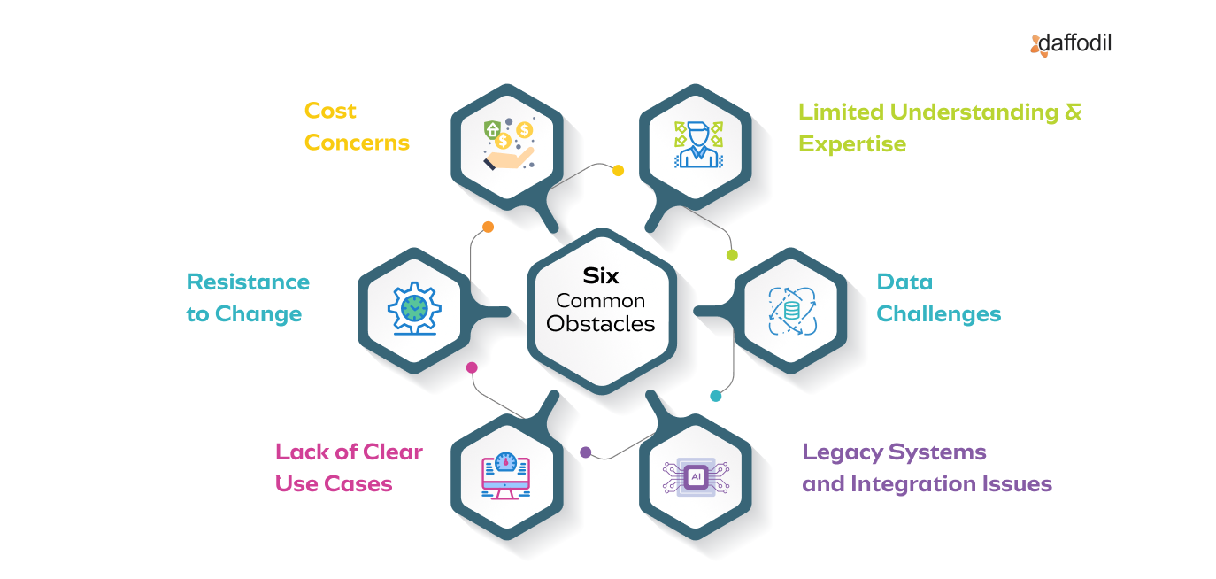

#### 8. Human-AI Collaboration and Design Refinement

A key aspect of our discussion centers on the role of human designers in collaborating with AI systems during the design process. We emphasize the importance of human oversight and refinement in interpreting and adapting AI-generated concepts to meet specific design criteria. We highlight strategies for effective human-AI collaboration, such as iterative design cycles and interactive interfaces that facilitate real-time feedback and adjustments.

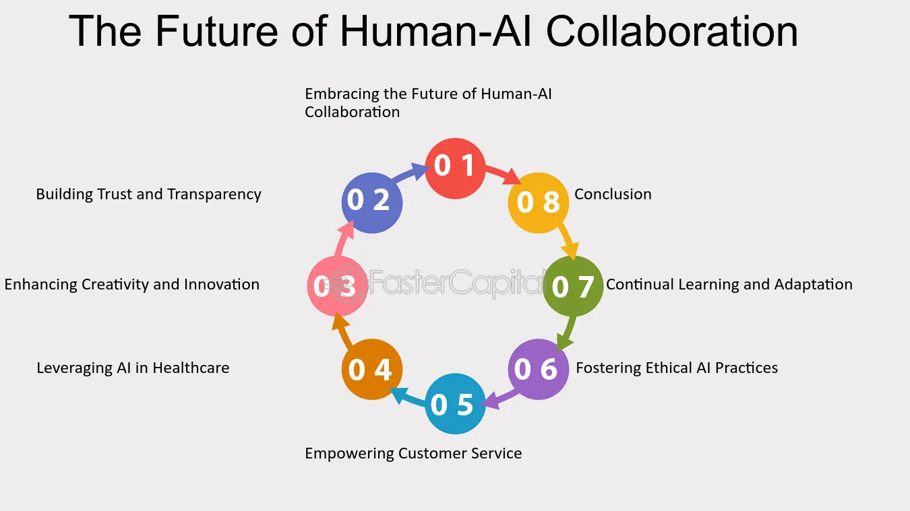

#### 9. Operationalization and Management

This section covers the operationalization and management aspects of deploying the proposed AI system in real-world settings. We discuss considerations such as data management, model deployment, monitoring, and maintenance. We outline strategies for ensuring the system's reliability, scalability, and security, as well as ongoing updates and optimizations to keep pace with evolving user needs and technological advancements.

#### 10. Technical Challenges and Future Directions

We identify technical challenges and potential future directions for advancing AI-driven text-to-visual synthesis. These include enhancing model robustness and generalization, improving interpretability and explainability, and exploring novel architectures and algorithms. We discuss the importance of interdisciplinary collaboration and knowledge sharing in driving innovation and addressing complex research challenges.

# Appendix:

The appendix provides supplementary information to complement the main body of the research proposal. It includes a comprehensive risk assessment, categorizing potential risks into technical, market, and operational domains, along with mitigation strategies to address each risk effectively.

# Risk Assessment:

### 1. Technical Risks

Technical risks pertain to challenges and uncertainties related to the development and implementation of the AI system. The following table outlines potential technical risks, their impact, and mitigation strategies:

|  |  |  |
| --- | --- | --- |
| Risk Description | Impact | Mitigation Strategy |
| Model Overfitting | Reduced Performance | Regularization techniques, cross-validation, and early stopping during training. |
| Data Quality and Availability | Model Inaccuracy | Rigorous data preprocessing, augmentation, and validation procedures. |
| Computational Complexity | Increased Resource Usage | Optimization techniques, parallel processing, and efficient algorithm design. |

### 2. Market Risks

Market risks involve factors that may affect the adoption, acceptance, or viability of the AI system in the market. The table below outlines potential market risks and mitigation strategies:

|  |  |  |
| --- | --- | --- |
| | Risk Description | Impact | Mitigation Strategy |
| Competitor Innovation | Loss of Market Share | Continuous monitoring of competitor developments, agile adaptation, and differentiation through unique features. |
| Regulatory Compliance | Legal and Reputational Risks | Thorough understanding of regulations, compliance frameworks, and proactive engagement with regulatory bodies. |
| Market Saturation | Limited Growth Opportunities | Diversification of target markets, expansion into niche sectors, and continuous innovation to maintain competitiveness. |

### 3. Operational Risks

Operational risks encompass challenges related to the day-to-day operation and management of the AI system. The table below outlines potential operational risks and mitigation strategies:

|  |  |  |
| --- | --- | --- |
|  |  |  |
| Data Security Breach | | Data Loss, Legal Consequences | Implementation of robust security measures, encryption protocols, and regular security audits. |
| System Downtime | Disruption of Services | Implementation of redundant systems, disaster recovery plans, and proactive monitoring for early detection and resolution of issues. |
| Skills Shortage | Decreased Productivity | Ongoing training programs, recruitment of skilled personnel, and collaboration with external experts or consultants |

This appendix provides a comprehensive risk assessment, categorizing potential risks into technical, market, and operational domains, along with mitigation strategies to address each risk effectively. By addressing potential risks and implementing proactive mitigation strategies, the appendix contributes to the overall risk management framework of the research proposal, enhancing its feasibility, robustness, and likelihood of success. This highlights the content and purpose of the appendix, emphasizing its role in providing additional context and insights to support the main body of the research proposal.

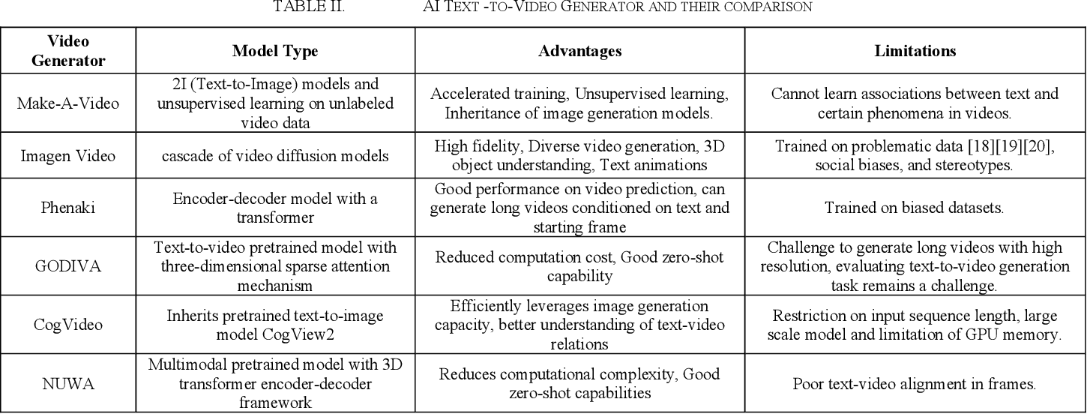

# Conclusion:

In conclusion, the research proposal outlines a pioneering approach for advancing text-to-visual synthesis through the integration of Text-to-Image (T2I) and Text-to-Video (T2V) technologies. By bridging the gap between static image generation and dynamic video synthesis, the proposed AI system promises to revolutionize content creation, education, and creative industries. Through rigorous risk assessment and mitigation strategies, the proposal ensures the robustness, reliability, and scalability of the AI system, paving the way for seamless integration into professional workflows.

The proposed research not only offers practical solutions for automating visual content generation but also emphasizes the importance of human-AI collaboration in the design process. By empowering users to generate high-quality visuals from simple textual descriptions, the AI system accelerates innovation, fosters interdisciplinary collaboration, and enhances creativity in engineering design and creative endeavors. Looking ahead, further research and development are needed to refine and optimize the proposed AI system, explore new applications and use cases, and advance the field of text-to-visual synthesis in the digital age.